**12. ReactJS-HOL**

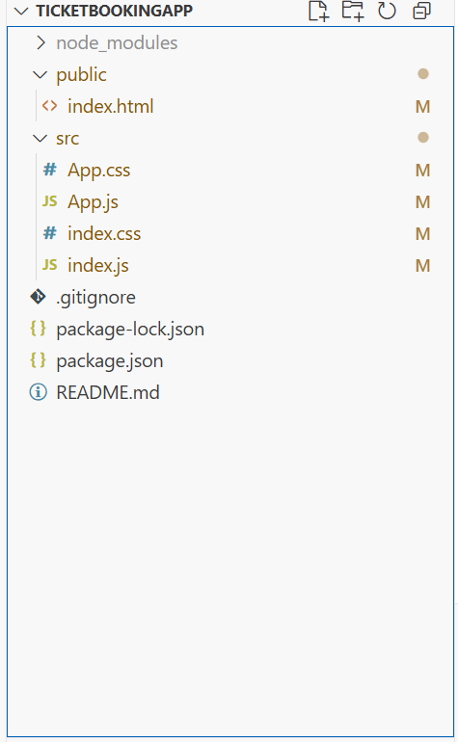

**Index.js**  
import React from "react";

import ReactDOM from "react-dom/client";

import "./index.css";

import App from "./App";

const root = ReactDOM.createRoot(document.getElementById("root"));

root.render(<App />);

**App.js**import React, { useState } from "react";

import "./App.css";

// Login Button Component

function LoginButton(props) {

return (

<button onClick={props.onClick}>

Login

</button>

);

}

// Logout Button Component

function LogoutButton(props) {

return (

<button onClick={props.onClick}>

Logout

</button>

);

}

function GuestGreeting() {

return (

<div>

<h2>Please sign up.</h2>

<p>Browse available flights below:</p>

<ul>

<li>✈️ Flight A123 – Chennai → Delhi</li>

<li>✈️ Flight B456 – Mumbai → Bangalore</li>

<li>✈️ Flight C789 – Hyderabad → Kolkata</li>

</ul>

</div>

);

}

function UserGreeting() {

return (

<div>

<h2>Welcome back</h2>

<p>Book your tickets below:</p>

<form>

<label>

Flight Number:

<input type="text" placeholder="Enter flight number" />

</label>

<br /><br />

<label>

Passenger Name:

<input type="text" placeholder="Enter your name" />

</label>

<br /><br />

<button type="submit">Book Ticket</button>

</form>

</div>

);

}

function Greeting(props) {

const isLoggedIn = props.isLoggedIn;

if (isLoggedIn) {

return <UserGreeting />;

}

return <GuestGreeting />;

}

function App() {

const [isLoggedIn, setIsLoggedIn] = useState(false);

const handleLoginClick = () => {

setIsLoggedIn(true);

};

const handleLogoutClick = () => {

setIsLoggedIn(false);

};

return (

<div className="container">

<Greeting isLoggedIn={isLoggedIn} />

{isLoggedIn ? (

<LogoutButton onClick={handleLogoutClick} />

) : (

<LoginButton onClick={handleLoginClick} />

)}

</div>

);

}

export default App;

**index.css**

body {

margin: 0;

padding: 0;

background-color: #ffffff;

}

**App.css**  
.container {

padding: 30px;

font-family: Arial, sans-serif;

text-align: center;

}

h2 {

font-size: 24px;

font-weight: bold;

margin-bottom: 10px;

}

p {

font-size: 16px;

}

button {

margin-top: 15px;

padding: 8px 16px;

font-size: 14px;

border: 1px solid #ccc;

background-color: #f8f8f8;

cursor: pointer;

border-radius: 4px;

}

button:hover {

background-color: #e6e6e6;

}

ul {

list-style: none;

padding: 0;

}

ul li {

font-size: 16px;

margin: 6px 0;

}

